Part 1
- Explain the concept of file modes in Python. Provide a brief description of at least three file modes commonly used in file handling. How does the choice of mode affect the way a file is opened and processed?
- Discuss the difference between writing and appending to a file in Python. When would you choose one over the other? Provide an example scenario where appending to a file is more suitable than writing to it.
- Enumerate and explain three best practices for proper file handling in Python. Consider aspects such as opening and closing files, error handling, and resource management.
- Discuss the potential consequences of not closing a file explicitly. How does Python handle file closing when using the with statement, and why is it considered a good practice in file handling?

Part 2
- Create a program in Python that opens a file named 'datafile.txt' for reading and assigns identifier input_file to the file object created.
- Create a program in Python that opens a file named 'datafile2.txt' for writing and assigns identifier output_file to the file object created.
- Assume that input_file is a file object for a text file open for reading, and output_file is a file object for a text file open for writing. Explain the contents of the output after the following code terminates:

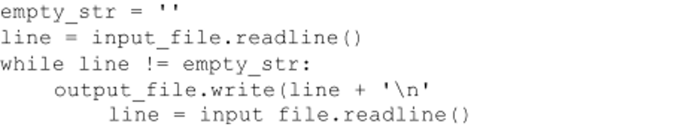
- Identify the error in the following code:

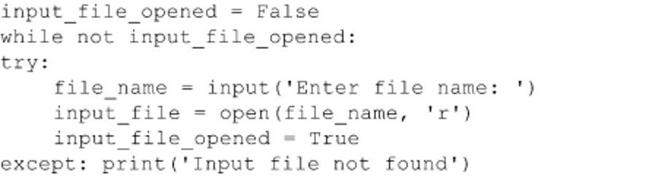

Part 3
- Write a Python function called reduce_spaces that is given a line read from a text file and returns the line with all extra space characters removed:
‘This line has extra space characters’ → ’This line has extra space characters’

- Write a Python function named extract_temp that is given a line read from a text file and displays the one number (integer) found in the string:

’The high today will be 75 degrees’ → 75.

- Write a Python function named check_quotes that is given a line read from a text file and returns True if each quote character in the line has a matching quote (of the same type), otherwise returns False.

‘Today’s high temperature will be 75 degrees’ → False

- Write a Python function named count_letters that is given a line read from a text file and returns a list containing every letter in the line and the number of times that each letter appears (with upper/lower case letters counted together)

‘This is a line’ → [ (‘t’, 1), (‘h’, 1), (‘i’, 3), (‘s’, 2), (‘a’, 1), (‘l’, 1), (‘n’, 1), (‘e’, 1) ]

- Write a Python function named interleave_chars that is given two lines read from a text, and returns a single string containing the characters of each string interleaved: ‘Hello’,

‘Goodbye’ → ‘HGeololdobye’

- Give a for loop that counts all the characters in a string assigned to a variable line, except blanks and the newline character.

- For a variable month which contains the full name of any given month, give an expression to display just the first three letters of the month.

- Give an expression that displays True if the letter ‘r’ appears in a given month name stored in a variable month, otherwise displays False.

- Give an expression for determining how many times the letter ‘r’ appears in a given month name stored in a variable month.

- For a person’s first name stored in variable first_name, and last name stored in variable last_name, give an expression that displays the person’s name formatted exactly as follows: Jones, William.

- Give an instruction that determines if a given social security number represented as a string and stored in variable ss_num, contains any non- digits.

- Give an instruction that determines the index of the ‘@’ character in an email address stored in variable email_addr.

- For a variable named date containing a date in the form 12/14/2012, give an expression that replaces all slashes characters with dashes.

- For a variable named err_mesg that contains error messages in the form ** error message **, give an expression that produces a string containing the error message without the leading and trailing asterisks and blank characters.

Part 4
Write a Python program that encrypts and decrypts text files using a substitution cipher. Your program should ask the user for the name of a text file and whether they would like to encrypt or decrypt. Once the process is complete, you should write the output to a new text file with a modified name:

This program will encrypt and decrypt text files
Enter (e) to encrypt a password, and (d) to decrypt: e
Enter the name of a text file to encrypt: hello.txt

Output written to: encrypted_hello.txt
Your program should catch exceptions and print helpful error messages. You should use your solution to Coding Challenge 04 to help you.

